Case Study 7: Fuel Consumption and Route Cost

1. Problem Statement
Calculate fuel required for a journey and its total fuel cost.

2. Objectives
- Calculate fuel needed from distance and mileage.
- Calculate the total cost.

3. Assumptions
- Distance and mileage must be positive.
- Fuel price is per litre.

4. Algorithm
1. Read distance, mileage, and fuel price.
2. Validate values.
3. Fuel needed = distance / mileage.
4. Cost = fuel needed * fuel price.
5. Display results.

5. Flowchart
START → Input distance, mileage, fuel price → Validate → Calculate fuel → Calculate cost → Display → STOP
For a drawn flowchart, use: oval for START/STOP, parallelogram for input/output, rectangle for calculations, and diamond for decisions.

6. Pseudocode
READ distance, mileage, price
IF distance < 0 OR mileage <= 0 OR price < 0: DISPLAY invalid
ELSE fuel = distance / mileage
cost = fuel * price
DISPLAY fuel, cost

7. Python Source Code
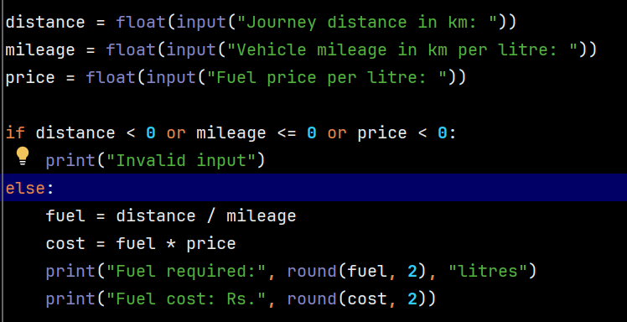

8. Test Cases
Test 1: 150 km, 15 km/litre, ₹100/litre → 10 litres, ₹1000. Test 2: 100 km, 20 km/litre, ₹95/litre → 5 litres, ₹475.

Sample Output
Input: distance 150 km, mileage 15 km/litre, fuel price ₹100/litre
Output: Fuel required: 10.0 litres
Fuel cost: Rs. 1000.0

9. Conclusion
The program calculates fuel requirements and journey cost using arithmetic operators.

